# CS 255 System Design Document (Henly)

## UML Diagrams

### UML Use Case Diagram

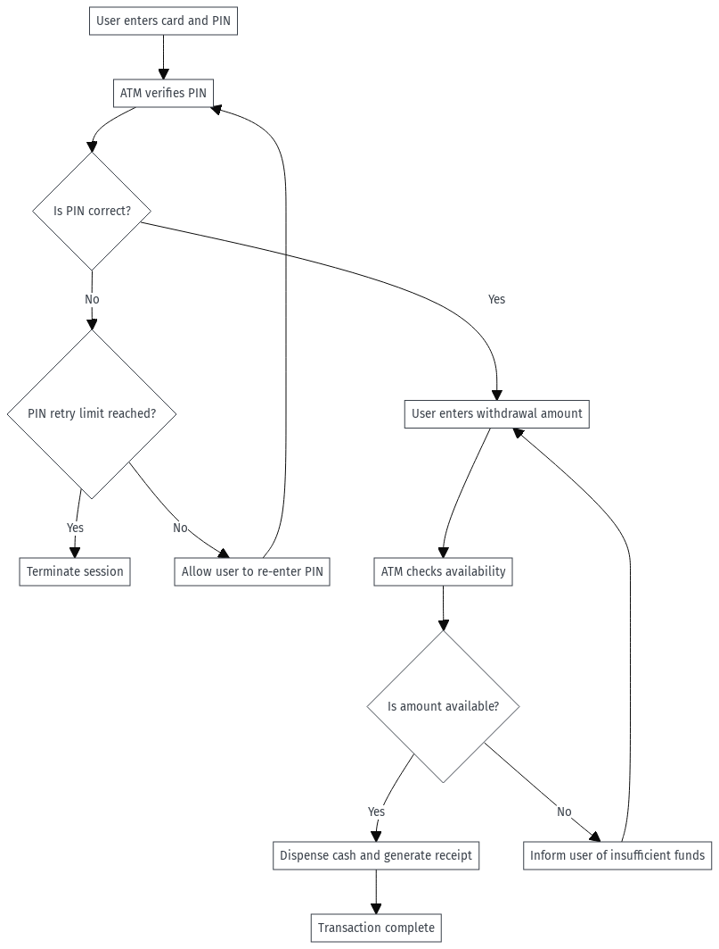

### UML Activity Diagrams

*Activity Diagram 1:*

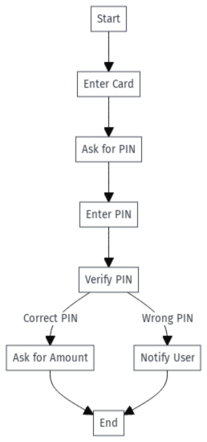

*Activity Diagram 2:*

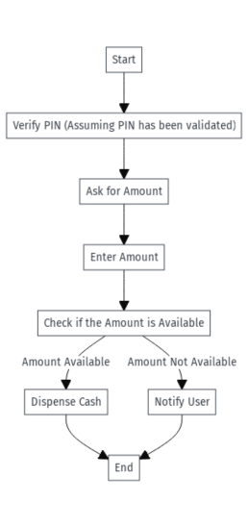

### UML Sequence Diagram

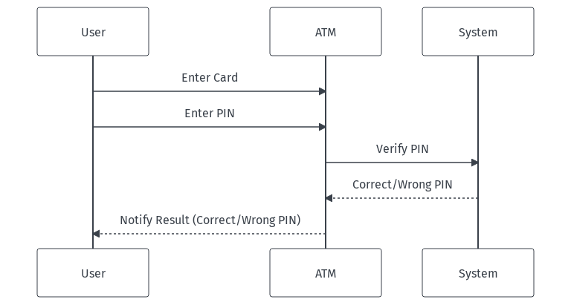

### UML Class Diagram

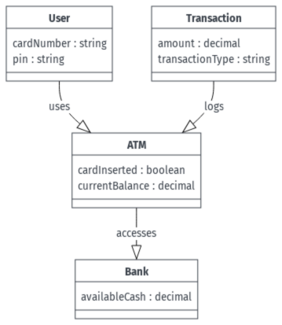

## Technical Requirements

### *Hardware Requirements:*

* *Utilize high-performance, multi-core servers such as Intel Xeon or AMD EPYC. These are essential for managing numerous connections and processing data in real-time.*
* *Minimum 16 GB of RAM to ensure efficient data management and effective multitasking.*
* *Equip with high-speed SSDs, at least 1 TB, to facilitate quick access to databases and application files, and to provide scalability.*
* *Incorporate redundant power supplies and network connections to increase system dependability and uptime.*

### *Software Requirements:*

* *Supports contemporary desktops and laptops running operating systems like Windows, macOS, or Linux.*
* *Also compatible with the latest mobile devices using iOS or Android.*

### *Server Environment:*

* *Utilize Apache, Nginx, or IIS, optimized for high concurrency and secure operations.*
* *Employ RDBMS like MySQL, PostgreSQL, or Oracle for effective structured data management.*
* *Integrate ORM frameworks to streamline database interactions.*

### *Development Tools:*

* *Use HTML5, CSS3, and JavaScript for building the front end, utilizing frameworks such as React or Angular to ensure responsive design.*
* *Back end development should leverage Python, Java, or Node.js, with appropriate frameworks like Django, Spring Boot, or Express.js to enhance security and ease of maintenance.*

### *Security Measures:*

* *Secure data transmissions with SSL/TLS.*
* *Encrypt sensitive data stored in databases to ensure privacy.*
* *Implement OAuth and JWT for robust user authentication.*
* *Enable Multi-factor Authentication (MFA) to bolster security.*

### *Network and Cloud Infrastructure:*

* *Deploy services on cloud platforms like AWS, Azure, or Google Cloud to take advantage of managed databases, and features like auto-scaling and load balancing.*
* *Utilize cloud-based storage for reliable data backup and disaster recovery.*
* *Ensure a high-speed internet connection with failover capabilities to maintain uninterrupted service.*
* *Set up firewalls, routers, and switches tailored for optimal traffic management and security.*

### *Maintenance and Monitoring:*

* *Employ monitoring tools like Nagios, Prometheus, or New Relic for system health and performance oversight.*
* *Use log management tools like ELK Stack or Splunk for thorough analysis and monitoring.*

### *Compliance:*

* *The system must comply with GDPR, HIPAA, or other relevant regulations, ensuring data protection and privacy.*

### *Testing and Deployment:*

* *Implement automated testing tools like Selenium, JUnit, or Jest for comprehensive frontend and backend validation.*
* *Employ CI/CD pipelines through tools like Jenkins, GitLab CI, or GitHub Actions for efficient deployment.*

### *Documentation and Training:*

* *Provide detailed user guides and online support resources.*
* *Conduct training sessions for administrators and users to familiarize them with the system.*